Course Code & Name | DSA01 - Object Oriented Programming with C++
Assignment Title | Smart Hospital Bed & Patient Monitoring Management System using C++
Course Outcome(s) – CO | CO1, CO2, CO3
Bloom’s Taxonomy Level | L3 – Apply; L4 – Analyse
SDG Mapping (SDG 1-17) | SDG 3 – Good Health and Well-being; SDG 9 – Industry, Innovation and Infrastructure

Functional Requirements
Smart Hospital Bed & Patient Monitoring Management System Using C++
The system shall provide the following functional requirements:
1. Patient Registration
- Register a unique Patient ID.
- Store the patient's name, age, diagnosis, and patient category.
- Patient categories include:
  - General Patient
  - ICU Patient
  - Emergency Patient
- Store other relevant patient information required for admission and monitoring.
2. Bed Management
- Maintain a fixed number of hospital beds.
- Assign a unique number to each bed.
- Maintain the current status of every bed as:
  - Available
  - Occupied
- Display the complete bed-status list when requested.
3. Bed Allocation
- Search for an appropriate available bed.
- Allocate beds according to the patient's category and priority.
- Prevent allocation of an already occupied bed.
- Update the bed status immediately after allocation.
4. Admission Management
- Create an Admission Record when a patient receives a bed.
- Store admission ID, patient ID, bed number, admission date, and stay information.
- Maintain whether the admission is currently active or completed.
5. Monitoring Update
- Record monitoring information for admitted patients.
- Store the number of monitoring checks, service units, and daily observations.
- Apply different monitoring requirements according to patient category.
- Update the patient's monitoring record during the admission period.
6. Billing
- Calculate the patient's charges based on:
  - Patient category
  - Number of days stayed
  - Room/bed charges
  - Monitoring checks
  - Service units
  - Applicable service rates
- Display the current or estimated bill before discharge.
- Calculate the final bill during discharge.
7. Patient Discharge
- Locate the patient's active admission.
- Calculate the final bill.
- Close the admission record.
- Release the patient's occupied bed.
- Change the bed status to Available.
- Display the patient's discharge and billing summary.
8. Admission Comparison
- Allow two admission records to be compared.
- Compare records based on:
  - Length of stay, or
  - Current/final bill
- Use operator overloading to implement meaningful admission comparison.
9. Utilization Report
The system shall generate a report containing:
- Total number of beds
- Number of occupied beds
- Number of available beds
- Bed-utilization percentage
- Number of active admissions
- Total revenue
- Patient-category information where applicable
The utilization percentage shall be calculated as:
$$\text{Utilization Percentage}=\frac{\text{Occupied Beds}}{\text{Total Beds}}×100$$
10. Menu-Driven Interface
The system shall provide a clear console-based menu for all major operations.
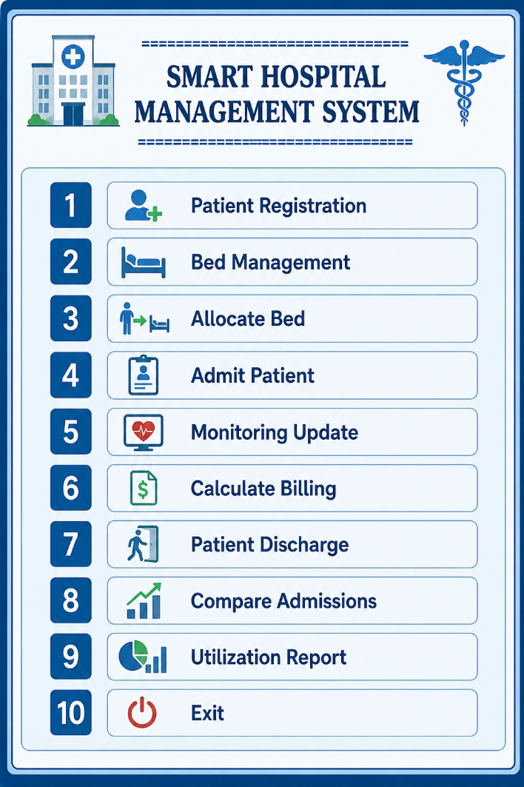
Enter your choice:
Functional Flow
Patient Registration
↓
Patient Category & Priority
↓
Check Available Bed
↓
Bed Allocation
↓
Admission Record
↓
Daily Monitoring
↓
Billing Calculation
↓
Patient Discharge
↓
Release Bed
↓
Update Utilization Report

Functional Requirements
Smart Hospital Bed & Patient Monitoring Management System Using C++
The system shall provide the following functional requirements:
1. Patient Registration
- Register a unique Patient ID.
- Store the patient's name, age, diagnosis, and patient category.
- Patient categories include:
  - General Patient
  - ICU Patient
  - Emergency Patient
- Store other relevant patient information required for admission and monitoring.
2. Bed Management
- Maintain a fixed number of hospital beds.
- Assign a unique number to each bed.
- Maintain the current status of every bed as:
  - Available
  - Occupied
- Display the complete bed-status list when requested.
3. Bed Allocation
- Search for an appropriate available bed.
- Allocate beds according to the patient's category and priority.
- Prevent allocation of an already occupied bed.
- Update the bed status immediately after allocation.
4. Admission Management
- Create an Admission Record when a patient receives a bed.
- Store admission ID, patient ID, bed number, admission date, and stay information.
- Maintain whether the admission is currently active or completed.

5. Monitoring Update
- Record monitoring information for admitted patients.
- Store the number of monitoring checks, service units, and daily observations.
- Apply different monitoring requirements according to patient category.
- Update the patient's monitoring record during the admission period.
6. Billing
- Calculate the patient's charges based on:
  - Patient category
  - Number of days stayed
  - Room/bed charges
  - Monitoring checks
  - Service units
  - Applicable service rates
- Display the current or estimated bill before discharge.
- Calculate the final bill during discharge.
7. Patient Discharge
- Locate the patient's active admission.
- Calculate the final bill.
- Close the admission record.
- Release the patient's occupied bed.
- Change the bed status to Available.
- Display the patient's discharge and billing summary.
8. Admission Comparison
- Allow two admission records to be compared.
- Compare records based on:
  - Length of stay, or
  - Current/final bill
- Use operator overloading to implement meaningful admission comparison.
9. Utilization Report
The system shall generate a report containing:
- Total number of beds
- Number of occupied beds
- Number of available beds
- Bed-utilization percentage
- Number of active admissions
- Total revenue
- Patient-category information where applicable
The utilization percentage shall be calculated as:
$$\text{Utilization Percentage}=\frac{\text{Occupied Beds}}{\text{Total Beds}}×100$$
10. Menu-Driven Interface
The system shall provide a clear console-based menu for all major operations.
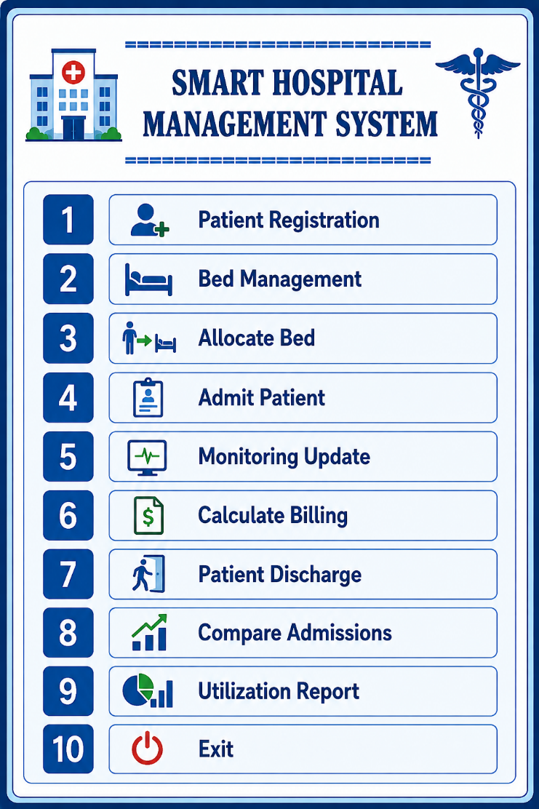
Enter your choice:
Functional Flow
Patient Registration
↓
Patient Category & Priority
↓
Check Available Bed
↓
Bed Allocation
↓
Admission Record
↓
Daily Monitoring
↓
Billing Calculation
↓
Patient Discharge
↓
Release Bed
↓
Update Utilization Report
Mandatory C++ / OOP Requirements
Smart Hospital Bed & Patient Monitoring Management System Using C++
The proposed system shall satisfy the following mandatory C++ and OOP requirements.
1. Encapsulation
All important data shall be kept inside classes using private or protected access specifiers. Public member functions shall control access to the data.
Example classes:
- Patient
- Bed
- AdmissionRecord
- MonitoringRecord
- HospitalSystem
class Bed {
private:
int bedNumber;
bool occupied;
int patientId;

public:
bool allocate(int id);
void release();
bool isAvailable() const;
};

2. Inheritance
A meaningful inheritance hierarchy shall be implemented for different patient categories.
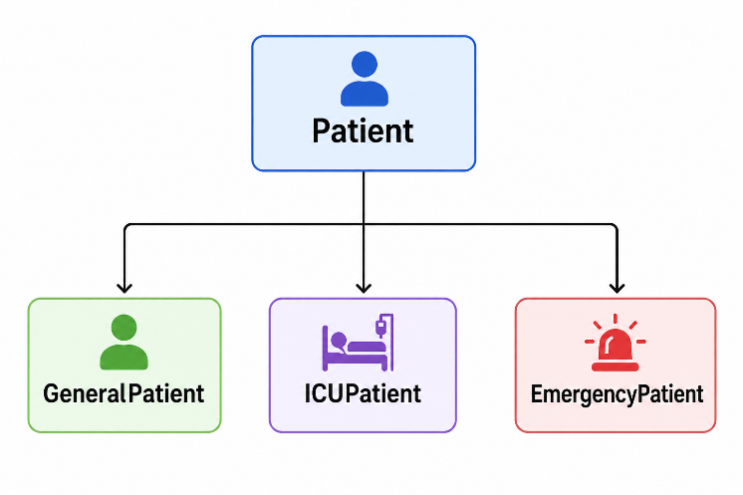
Each derived class shall represent different hospital requirements.
class GeneralPatient : public Patient { };
class ICUPatient : public Patient { };
class EmergencyPatient : public Patient { };

3. Polymorphism
Virtual functions shall be used in the base Patient class so that patient-specific behaviour is selected at run time.
class Patient {
public:
virtual double getDailyCharge() const = 0;
virtual string getMonitoringRequirement() const = 0;
virtual int getPriority() const = 0;

virtual ~Patient() {}
};
A base-class pointer can then refer to different patient types:
Patient* patient;

patient = new GeneralPatient(...);
cout << patient->getDailyCharge();

patient = new ICUPatient(...);
cout << patient->getDailyCharge();
Thus, the same function call produces different results depending on the actual patient type.

4. Constructors
Relevant classes shall implement:
Default constructor
Patient();
Parameterized constructor
Patient(int id, string name, int age, string diagnosis);
Copy constructor
Patient(const Patient& other);
These constructors shall initialize patient, bed, and admission information appropriately.

5. Destructor
Destructors shall be implemented for appropriate classes.
virtual ~Patient() {
// cleanup resources
}
For the admission/session management, cleanup shall ensure that an active bed is not left incorrectly marked as occupied. The system should release the associated bed when an admission is properly closed or when the owning session object is destroyed.
A safer design is to make discharge the normal operation for releasing the bed, while the destructor performs final cleanup for any remaining session resources.

6. Static Members
Static members shall maintain information shared by the entire hospital system.
For example:
class Patient {
private:
static int totalRegisteredPatients;

public:
Patient() {
totalRegisteredPatients++;
}

static int getTotalRegisteredPatients() {
return totalRegisteredPatients;
}
};
Possible shared information:
- Total registered patients
- Total admissions
- Total discharged patients
- Total revenue
Example:
cout << "Total Registered Patients: "
<< Patient::getTotalRegisteredPatients();

7. Arrays / Collections of Objects
Collections shall be used to manage multiple hospital objects.
vector<Bed> beds;
vector<Patient*> patients;
vector<AdmissionRecord> admissions;
For example:
vector<Bed> beds;

for (int i = 1; i <= 20; i++) {
beds.emplace_back(i);
}
This allows the hospital to maintain a fixed collection of beds while dynamically managing patients and admissions.

8. Operator Overloading
At least two meaningful operators shall be overloaded.
> Operator
Admission records can be compared according to length of stay or bill amount.
bool operator>(const AdmissionRecord& other) const {
return daysStayed > other.daysStayed;
}
Usage:
if (record1 > record2)
cout << "Record 1 has a longer stay.";
<< Operator
The insertion operator can format admission information for reports.
friend ostream& operator<<(
ostream& out,
const AdmissionRecord& record
) {
out << "Admission ID: " << record.admissionId << endl;
out << "Patient ID: " << record.patientId << endl;
out << "Bed Number: " << record.bedNumber << endl;
out << "Days Stayed: " << record.daysStayed << endl;
return out;
}

9. Control Structures
The application shall use:
- if/else for validation and decisions
- switch for menu selection
- for and while loops for repeated operations
- Input validation for patient and bed information
- Menu-driven control flow
Example:
do {
cout << "\n1. Register Patient";
cout << "\n2. Allocate Bed";
cout << "\n3. Monitoring Update";
cout << "\n4. Calculate Bill";
cout << "\n5. Discharge";
cout << "\n6. Report";
cout << "\n7. Exit";

cin >> choice;

switch (choice) {
case 1:
registerPatient();
break;

case 2:
allocateBed();
break;

case 3:
updateMonitoring();
break;

case 4:
calculateBill();
break;

case 5:
dischargePatient();
break;

case 6:
generateReport();
break;

case 7:
cout << "Exiting...";
break;

default:
cout << "Invalid choice!";
}

} while (choice != 7);

10. Run-Time Adaptation
Billing, monitoring, and priority shall automatically change according to the derived patient class.
Patient Type | Daily Charge | Monitoring | Priority
GeneralPatient | ₹1,500 | Normal | 1
ICUPatient | ₹5,000 | Continuous | 3
EmergencyPatient | ₹3,500 | Frequent | 2
For example:
Patient* p = new ICUPatient(...);

cout << p->getDailyCharge();
cout << p->getMonitoringRequirement();
cout << p->getPriority();
The program does not need to manually determine the patient's type before every operation. Virtual functions provide run-time polymorphism, allowing the correct billing, monitoring, and priority behaviour to be selected automatically.

Overall OOP Design
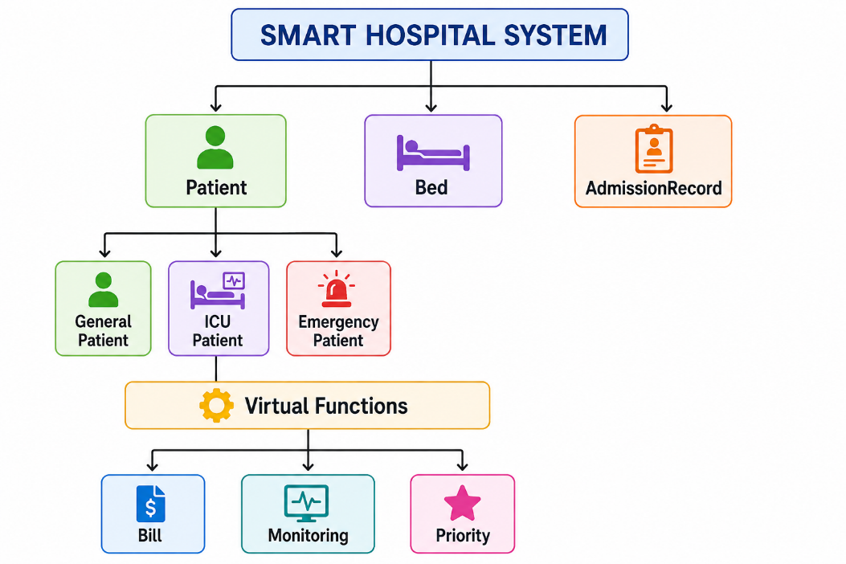
This design directly satisfies the mandatory requirements for encapsulation, inheritance, polymorphism, constructors, destructors, static members, object collections, operator overloading, control structures, and run-time adaptation.
Suggested Class Structure

Smart Hospital Bed & Patient Monitoring Management System Using C++
Class | Suggested Responsibility | OOP Feature
Patient | Stores common patient ID, name, age, diagnosis, and basic patient information. Defines common virtual functions for charge, monitoring, and priority. | Base class / Encapsulation / Polymorphism
GeneralPatient | Handles normal-ward patients, including standard monitoring and normal daily room/service charges. | Inheritance + Function Overriding
ICUPatient | Handles ICU patients with intensive monitoring requirements, higher daily charges, and high priority. | Inheritance + Function Overriding
EmergencyPatient | Handles emergency patients with priority-based allocation, frequent monitoring, and emergency service charges. | Inheritance + Function Overriding
HospitalBed | Stores bed number, ward type, occupancy status, and allocated patient ID. Provides functions for allocating and releasing beds. | Encapsulation
Admission | Maintains the patient-bed relationship, admission details, length of stay, monitoring/service usage, and bill calculation. Supports constructors, destructor, and operator overloading. | Constructors / Destructor / Operators / Encapsulation
Hospital | Manages collections of patients, beds, and admissions. Controls registration, allocation, monitoring, billing, discharge, reports, and the main menu. | Aggregation / Collections / Control Logic

Class Relationship
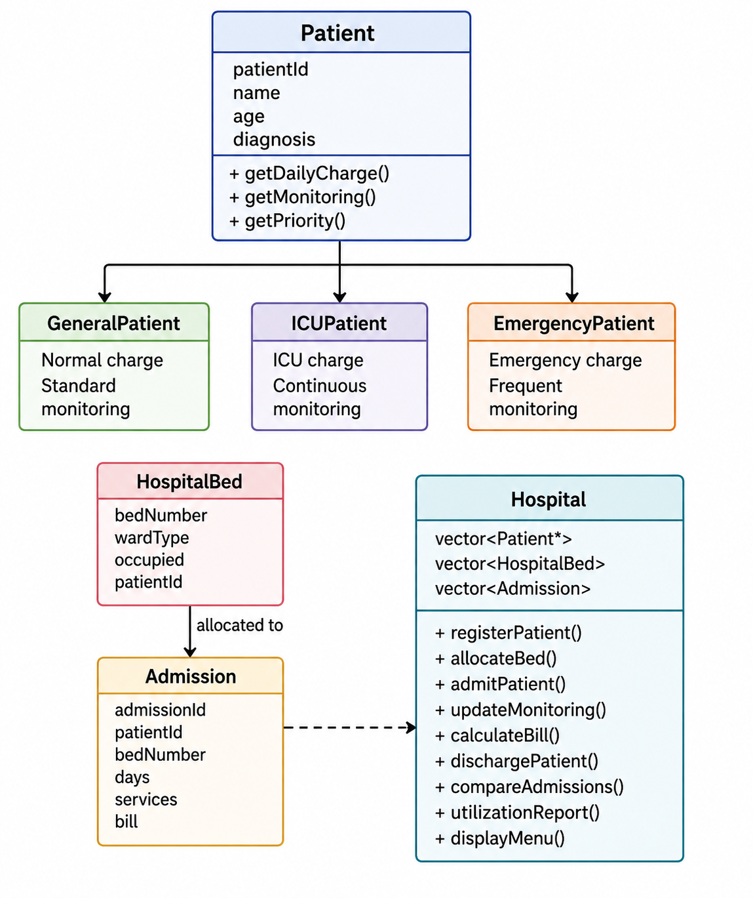
Key Design
- Patient → abstract/base class.
- GeneralPatient, ICUPatient, EmergencyPatient → derived classes.
- HospitalBed → manages individual bed status.
- Admission → connects a patient with an allocated bed and manages the stay.
- Hospital → aggregates all patients, beds, and admissions and provides the menu-driven workflow.
- Virtual functions → dynamically select patient-specific billing, monitoring, and priority.
- Operator overloading → can compare two Admission objects and format admission reports.

Suggested Billing Rules

Smart Hospital Bed & Patient Monitoring Management System Using C++
The following billing values can be implemented in the system. The values may also be changed to reasonable alternatives while maintaining the same functional behaviour.
Patient Type | Base Daily Bed Charge | Monitoring / Service Charge
General Patient | ₹2,000/day | ₹300 per monitoring/service unit
ICU Patient | ₹7,500/day | ₹1,000 per monitoring/service unit
Emergency Patient | ₹5,000/day | ₹750 per monitoring/service unit

Billing Formula
The total bill can be calculated as:
$$\text{Total Bill}=\left(\text{Daily Bed Charge}×\text{Days Stayed}\right)+\left(\text{Monitoring Units}×\text{Service Charge}\right)$$

Example
For a General Patient staying for 4 days with 5 monitoring/service units:
$$\left(2000×4\right)+\left(300×5\right) \\ =8000+1500 \\ =\boxed{\text{₹}9,500}$$
For an ICU Patient staying for 3 days with 6 monitoring/service units:
$$\left(7500×3\right)+\left(1000×6\right) \\ =22500+6000 \\ =\boxed{\text{₹}28,500}$$

C++ Implementation
These values can be implemented through polymorphic functions:
virtual double getDailyCharge() const = 0;
virtual double getServiceCharge() const = 0;
For example:
class GeneralPatient : public Patient {
public:
double getDailyCharge() const override {
return 2000.0;
}

double getServiceCharge() const override {
return 300.0;
}
};

class ICUPatient : public Patient {
public:
double getDailyCharge() const override {
return 7500.0;
}

double getServiceCharge() const override {
return 1000.0;
}
};

class EmergencyPatient : public Patient {
public:
double getDailyCharge() const override {
return 5000.0;
}

double getServiceCharge() const override {
return 750.0;
}
};
The Admission class can then calculate the bill using the patient object's virtual functions:
double calculateBill(const Patient& patient) const {
return (patient.getDailyCharge() * daysStayed)
+ (patient.getServiceCharge() * serviceUnits);
}

This ensures that the billing automatically adapts at run time according to the patient's derived class.
Expected Menu
Smart Hospital Bed & Patient Monitoring Management System Using C++
The application shall provide the following menu-driven console interface:
========================================================
SMART HOSPITAL BED & PATIENT MONITORING SYSTEM
========================================================

1. Register Patient
2. Display All Patients
3. Display All Beds
4. Admit Patient / Allocate Bed
5. Update Monitoring or Service Usage
6. Calculate Current Bill
7. Discharge Patient
8. Display Admission Records
9. Compare Two Admissions
10. Generate Bed Utilization Report
11. Exit

========================================================
Enter your choice:
Menu Operation Description
Option | Operation | Functionality
1 | Register Patient | Enter patient ID, name, age, diagnosis, and category.
2 | Display All Patients | Display all registered patients and their categories.
3 | Display All Beds | Show bed number, ward type, and availability/occupancy status.
4 | Admit Patient / Allocate Bed | Select a registered patient and allocate a suitable available bed based on category and priority.
5 | Update Monitoring or Service Usage | Add monitoring checks or service units to an active admission.
6 | Calculate Current Bill | Calculate the current bill using stay duration and monitoring/service usage.
7 | Discharge Patient | Calculate the final bill, close the admission, and release the occupied bed.
8 | Display Admission Records | Display active and completed admission records.
9 | Compare Two Admissions | Compare two admission records using an overloaded comparison operator.
10 | Generate Bed Utilization Report | Display total beds, occupied beds, available beds, utilization percentage, active admissions, and revenue.
11 | Exit | Terminate the application safely.
Menu Flow
Register Patient
↓
Display Patients
↓
Display Beds
↓
Admit / Allocate Bed
↓
Update Monitoring / Services
↓
Calculate Current Bill
↓
Discharge Patient
↓
Display Admission Records
↓
Compare Admissions
↓
Generate Utilization Report
↓
Exit
This menu provides the complete Smart Hospital Bed & Patient Monitoring Management System workflow while allowing all major operations to be performed through a simple console interface.


